|  |
| --- |
| How to setup a Serenity project |
| ELCA.VN |
| On boarding exercise |

|  |  |  |  |  |  |  |
| --- | --- | --- | --- | --- | --- | --- |
| Imput. | Report | Version | Date | Author | Status | Visa |
|  |  | 0.1 | 15.05.16 | MHI |  |  |
| © ELCA Information Technology (Vietnam) Ltd. 2016. | | | | | | |

Table of Contents

1. Introduce Serenity project 2

1.1. Serenity project 2

1.2. Serenity components 3

2. Setup environment development 3

2.1. Java setup 3

2.2. Eclipse 5

2.3. Maven 6

3. Structure of serenity project 6

3.1. Feature 7

3.2. Steps 8

3.3. Pages 9

3.4. Configure maven 11

4. Building a serenity project in maven 13

5. Check result 14

# Introduce Serenity project

# Serenity project

Serenity project is java project to execute integrate test use BDD (Behavior Driven Development) or we call them is Serenity BDD. We can use Serenity BDD to write test cases cleaner and maintainable automated acceptance and regression tests faster. We can create Serenity project by many way, there are famous framework to create integrate project is Thucydides framework. It use junit type to build or run. Thucydides framework is supplies Testers organize and develop code easily. About Thucydides framework, we can refer it on link: <http://www.thucydides.info/docs/serenity/#introduction>

Serenity BDD provides strong support for automated web tests using [Selenium 2](http://docs.seleniumhq.org/projects/webdriver), though it also works very effectively for non-web tests such as tests that exercise web services or even call application code directly

# Serenity components

There are 3 tools Serenity BDD to develop a serenity project. That are:

* Cucumber
* JBehave
* Junit

There is a generally of them that is organize test case follow scenario and feature. That is use 3 keywords “Given”, “When” and “Then” by cleanly or none.

Here is example for a scenario in serenity project.

Given I open home page and focus on search field

When Input keyword and start searching

Then Results is displaying on page

Or as Junit

homepage.openHomePageToSearch(); //Given

homepage.inputKeywordToStartSearch(); //When

homepage.checkResultIsDisplaying(); // Then

This article will mention to how to create a Serenity project by Junit type use Thucydides framework. I try to develop sample project to cleanly and easily to have an overview on Serenity project.

# Setup environment development

To develop a Serenity project when need base software.

* Java
* Eclipse
* Maven

# Java setup

* Download and install java to machine, I suggest using JDK-1.8 for that

After install java we will see it in program file

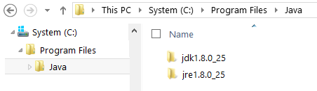

* Setup system variable:

We go there: **Control Panel > System and Security > System > Advanced system settings**

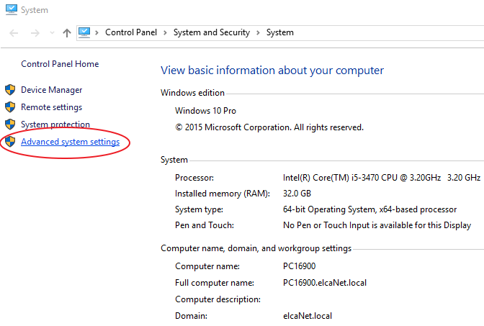

Add **JAVA_HOME**  and set to **Path:**

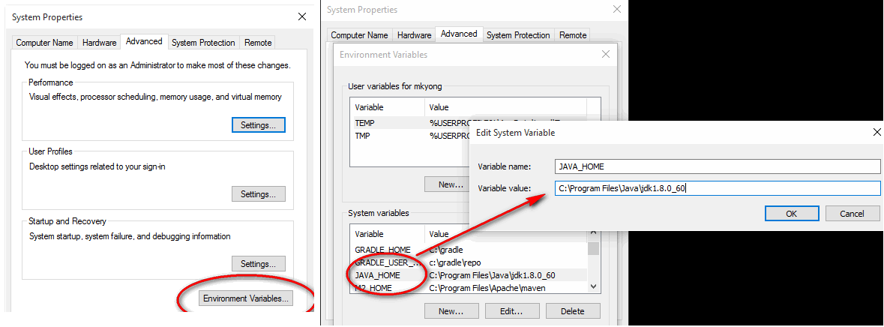

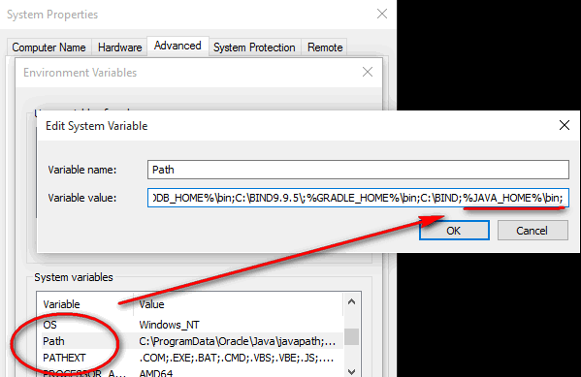

# Eclipse

We can using any eclipse IDE to develop a serenity project. Download Eclipse here (link: <https://eclipse.org/downloads> )

We should set maven setting for eclipse: “**Windown > Preferences > Maven > Setting**”

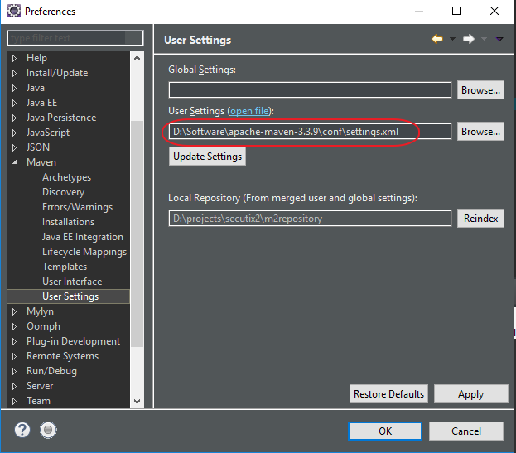

# Maven

* Download maven here: <https://maven.apache.org/download.cgi>
* Set up environment for maven like as Java JDK and check

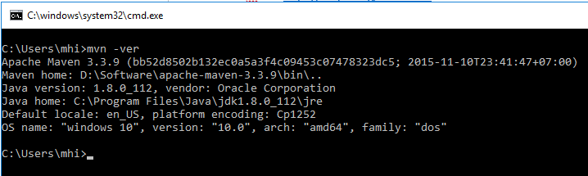

# Structure of serenity project

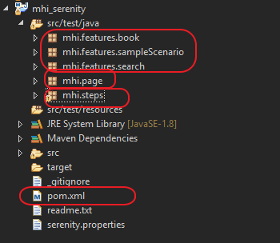

Here is structure project. Project is style of Maven with pom.xml to build and manage dependency

# Feature

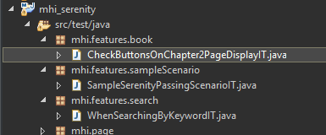

We have 3 suite.

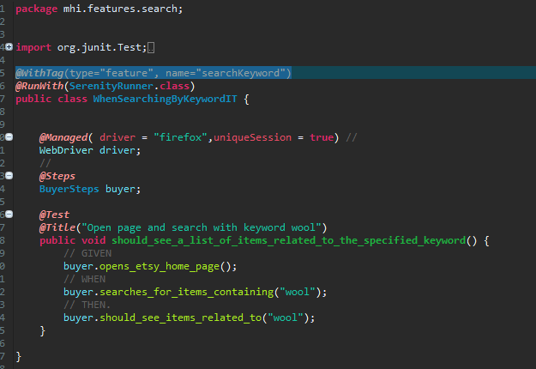

Here is sample of a suite.

**Name**: As a feature/suite is storage in a packages “*.features.*” . Because serenity test is testing as a integrate testing (IT) level so name of suite is with rule:

* Cameling style with end by **IT.java
* Cameling style with begin by IT***.java
* Ex: **WhenSearchingByKeywordIT**

**@RunWith:** we marking *@RunWith(SerenityRunner.class)*

**@Managed( driver = "firefox",uniqueSession = true):** configure testcase run on Firefox browser or others.

**@Step:** The @Steps annotation marks a Serenity step library

**@Test:** Marking the function is a test case. The unit test is composed of logical steps, each of which will appear in the reports

**@Title:** an annotation lets you provide your own title for this test in the test reports

As a Test Suite that wtill call method of Serenity step library. Example: BuyerSteps will call all method from BuyerSteps class library

# Steps

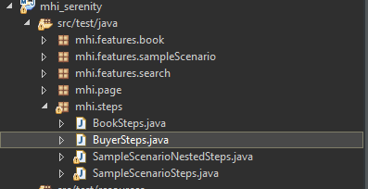

Steps package is storage all class Serenity step library.

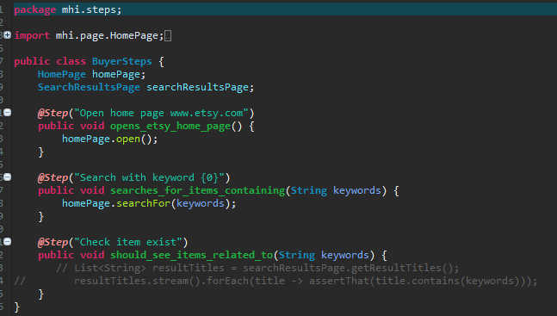

**@Step:** The @Step annotation marks this as a method that will be recorded and will appear in the test report

This class contain all method to call from feature or Call another object. Example: HomePage will supply method to finish a step. HomePage class will storage in Pages package

# Pages

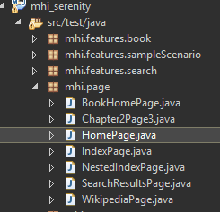

A page is define of a real page, contain element, and behavior on a page.

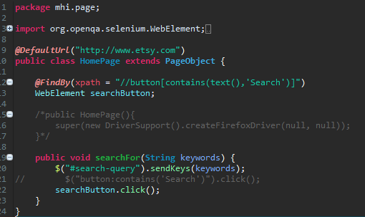

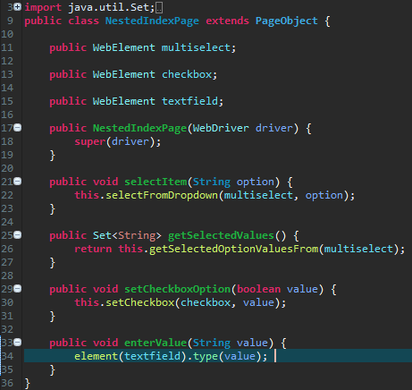

# Configure maven

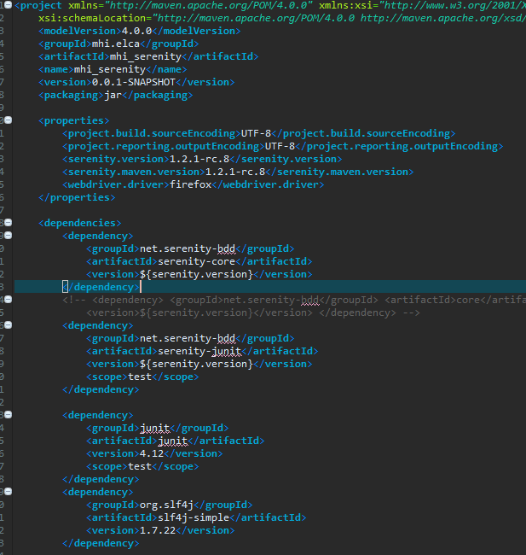

Because this maven project so we manage lib though dependencies. Here is sample.

We add plugin to build. add “*maven-surefire-plugin*”, “*maven-failsafe-plugin*” and “*serenity-maven-plugin*”

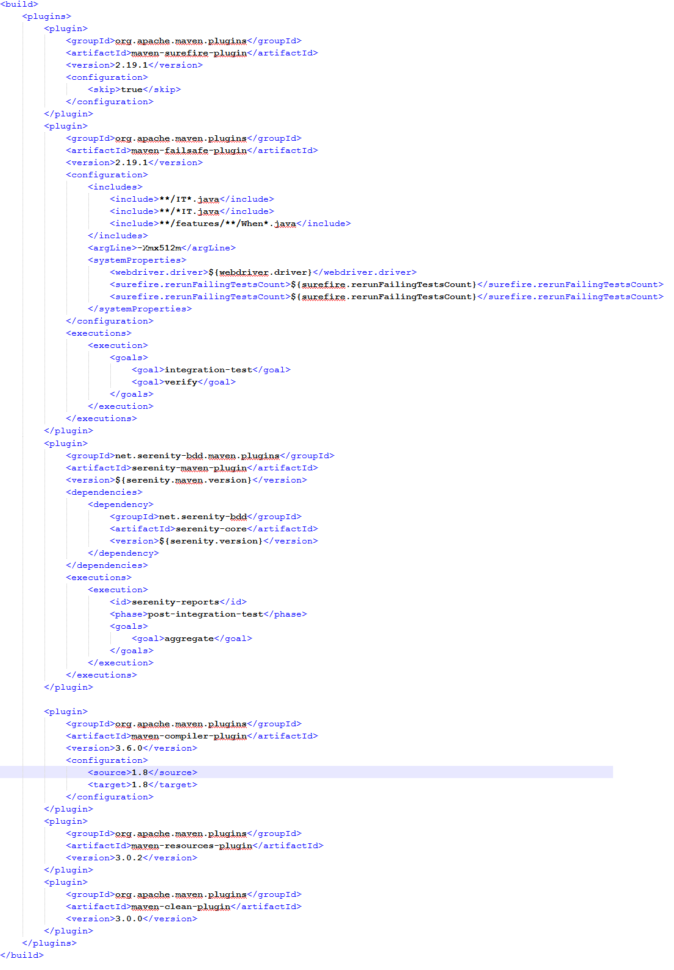

For “*maven-failsafe-plugin*”

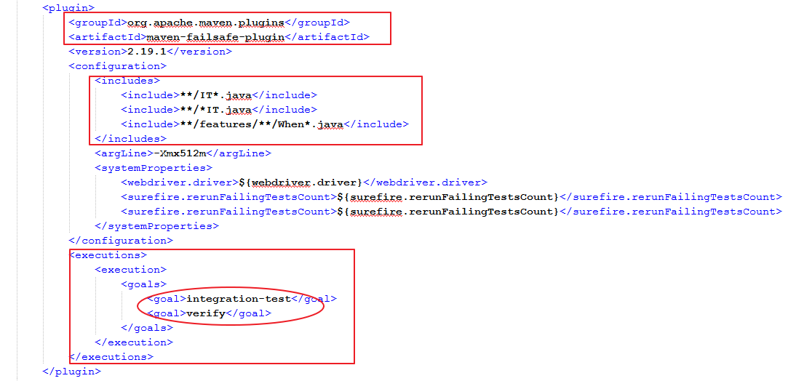

* **Includes:** where serenity will search to start a suite test.
* **Executions:** Configure how serenity build. here serenity will build project as a “**integaration-test**” and “**Verify**”

# Building a serenity project in maven

Serenity project managed create instance drivers. So we can’t set special web driver as Chromedriver for chrome or GeckoDriver for Firefox. So we will using selenium Grid and maven to create connection, and set webdriver.

Here is a sample; command: “*mvn verify -Dwebdriver.remote.url=http://localhost:4444/wd/hub -Dwebdriver.remote.driver=chrome -Dwebdriver.remote.os=WINDOWS*”

Before we run above command. We should start a grid as hub and nodes to call driver

(Note: below command is a sample)

* **Create Hub: “***java -jar selenium-server-standalone-3.0.1.jar -role hub***”**
* **Create node: “***java -jar -Dwebdriver.gecko.driver="geckodriver-v0.11.1.exe" selenium-server-standalone-3.0.1.jar -role node -hub http://localhost:4444/grid/register -port 5566 -browser browserName=firefox,maxInstances=2 -browser browserName=chrome,maxInstances=2 -browser browserName=MicrosoftEdge,maxInstances=2 -maxSession 2* **”**
* **Note:**  from selenium 3.**.jar or later, when create a node. We should move cmd set WebDriver (*-Dwebdriver.gecko.driver="geckodriver-v0.11.1.exe")*  to font of create a node (*selenium-server-standalone-3.0.1.jar -role node* )

Last: We call mvn command to run test. The test will start with chrome browser

*“mvn verify -Dwebdriver.remote.url=http://localhost:4444/wd/hub -Dwebdriver.remote.driver=chrome -Dwebdriver.remote.os=WINDOWS*”

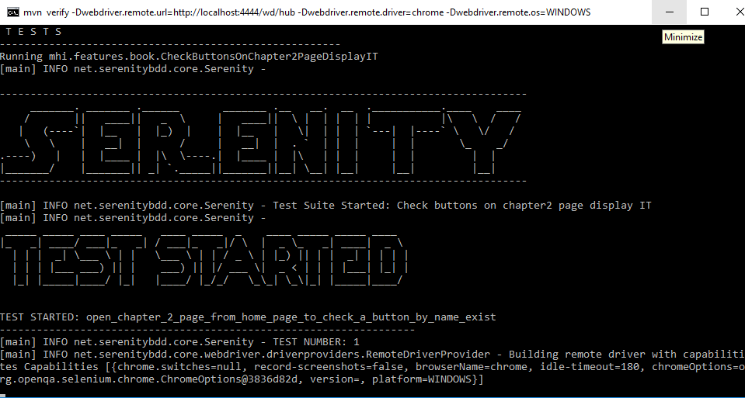

# Check result

Result of serenity project is created in “…**Project/Target/site/Serenity**”.

There are many file was generated by serenity report. Bug we focus to “**index.html**” when open it on web browser.

